SIMATS ENGINEERING
ASSESSMENT TOOL 1

Experiments

COURSE NAME: OBJECT ORIENTED ANALYSIS AND DESIGN COURSE CODE: CSA1110

COURSE OUTCOME COVERED

CO3: Analyze system requirements using object-oriented techniques to identify classes, attributes, and relationships and develop use case models. (BL4)

Assessment Tool Weightage: 40%

QUESTIONS:4 Total Marks:40

- Develop a system using UML for implementing the Book Bank process. It should verify the details of the student by the central computer. The details regarding the student will be provided to the central computer through the administrator in the book bank and the computer will verify the details of the student and provide approval to the office. Then the books that are needed by the student will issue from the office to him.

- Develop a system using UML for implementing the Exam Registration Portal. It should verify the details of the candidate by the central computer. The details regarding the candidate will be provided to the central computer through the administrator and the computer will verify the details of the candidate and provide approval. Then the hall ticket will be issued from the office to the candidate.

- Develop a system using UML for implementing Stock Maintenance System. In this system, the customer can place orders and purchase items with the aid of the stock dealer and central stock system. These orders are verified and the items are delivered to the customer. Then the stock details are to be updated accordingly.

- Develop a system using UML for implementing Online Course Reservation System. This system is organized by the central management system. The student first browses and selects the desired course of their choice. The university then checks the availability of the seat if it is available the student is enrolled for the course.

Code of Conduct:
I LOSHINI.L 192571015 (Name / Reg No) certify that this submission is my original work and that I have adhered to the guidelines specified for this assessment.
I understand that any violation of academic integrity rules will result in disciplinary action
Signature of the student:
LOSHINI.L

RUBRICS FOR CALCULATION:

Experiments

Criteria | Weightage | Level 4 – Exemplary | Level 3 –  Proficient | Level 2 –  Developing | Level 1 –  Beginning
Understanding of Concepts | 25 | Demonstrates thorough understanding and effectively integrates multiple concepts/technologies | Good understanding with proper integration of most concepts | Basic understanding; limited or partial integration | Poor understanding; unable to integrate concepts
Experimental Design | 30 | Well-planned, systematic implementation with  optimal solution | Correct implementation with minor  issues | Basic implementation with errors or  inefficiencies | Incorrect or incomplete implementation
Use of Tools | 20 | Effective and advanced use of tools/technologies with  proper configuration | Appropriate use of tools with correct  execution | Limited or inconsistent use of tools | Incorrect or minimal use of tools
Analysis of Results | 15 | Insightful analysis with accurate interpretation and validation of results | Good analysis with reasonable interpretation | Basic analysis with limited insights | Poor or incorrect analysis of results
Documentation | 10 | Clear, well-structured documentation with diagrams, code, and  results | Organized documentation with necessary  details | Basic documentation with missing  details | Poor or incomplete documentation

Question 1: Book Bank Management System

Problem Statement
The Book Bank system enables a student to obtain textbooks through the institution's book bank. The Administrator enters the details of the student into the central computer. The central computer verifies the details of the student and, upon successful verification, grants approval to the office. Once approval is received, the office issues the requested books to the student and updates the book bank records.

Actors Identified

Actor | Role in the System
Administrator | Collects and enters the student's details into the central computer for verification.
Central Computer | Verifies the student details received from the administrator and grants or withholds approval.
Student | Requests the required books once approval is granted.
Office Staff | Issues books to the approved student and maintains the book bank records.

Use Case Diagram
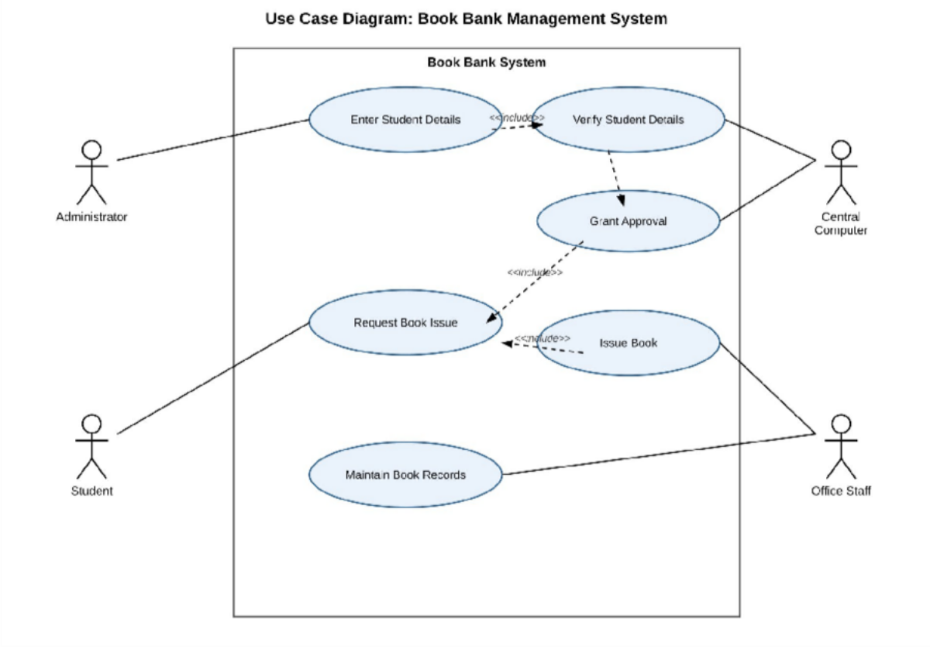
Fig. 1.1 — Use Case Diagram of the Book Bank Management System

The use case diagram shows four actors interacting with the Book Bank System. The Administrator initiates the process by entering the student's details, which includes (<<include>>) the Verify Student Details use case performed by the Central Computer. Successful verification leads to the Grant Approval use case. The Student independently raises a Request Book Issue use case, which is completed only after the Issue Book use case

(performed by Office Staff) includes the Grant Approval use case, ensuring that books are issued only to approved students. Office Staff additionally perform the Maintain Book Records use case to keep the book inventory current.

Classes Identified

Class | Key Attributes | Key Operations
Student | studentId, name, department, year, contactNo | requestBook(), viewStatus()
Administrator | adminId, name | enterDetails(), forwardToComputer()
CentralComputer | systemId | verifyDetails(), sendApproval()
Office | officeId, location | receiveApproval(), issueBook()
Book | bookId, title, author, isbn, copiesAvailable | updateAvailability()
BookBankRecord | recordId, studentId, bookId, issueDate, dueDate, status | createRecord(), updateRecord()

Class Diagram
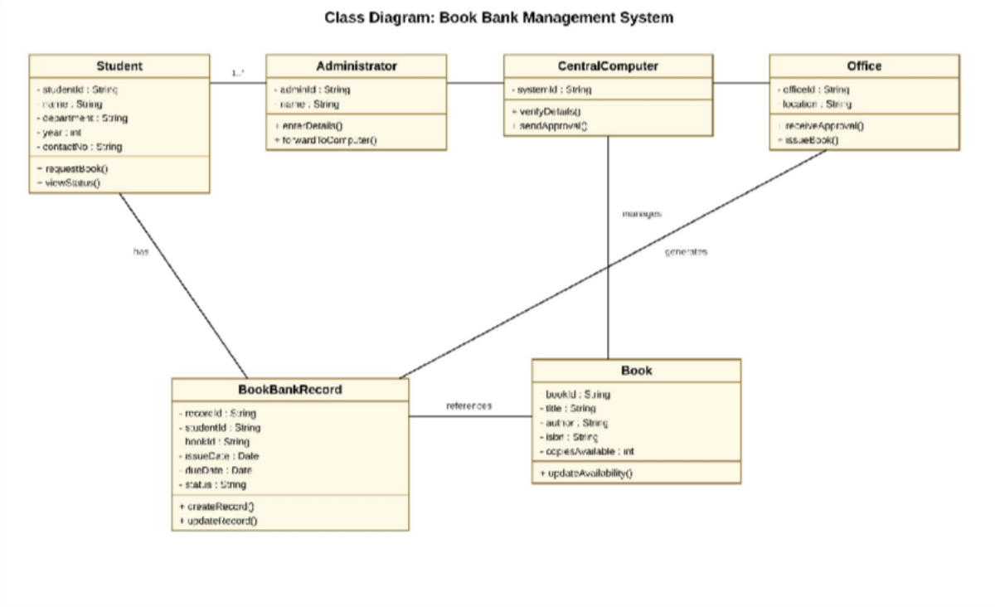
Fig. 1.2 — Class Diagram of the Book Bank Management System

The class diagram models the static structure of the Book Bank System. The Student and Administrator classes are associated (1..* — one administrator handles many students), and the Administrator forwards details to CentralComputer, which in turn notifies the Office. The CentralComputer manages the Book class (checking and approving issue requests), the Office generates a BookBankRecord for every transaction, the Student has an associated BookBankRecord, and each BookBankRecord references the Book that was issued.

Analysis of Relationships

The design cleanly separates responsibilities: data capture (Administrator), verification and decision-making (CentralComputer), and fulfilment/record-keeping (Office). The BookBankRecord class acts as an association/link class between Student and Book, capturing transactional attributes (issueDate, dueDate, status) that do not belong to either Student or Book individually. This structure allows the system to be extended in future — for example, to support fines for overdue books — without modifying the core Student or Book classes.

Question 2: Exam Registration Portal

Problem Statement
The Exam Registration Portal allows a candidate to register for an examination. The Administrator enters the candidate's details into the central computer. The central computer verifies these details and, if they are valid, approves the registration. Once the registration is approved, the office generates and issues the hall ticket to the candidate.

Actors Identified

Actor | Role in the System
Administrator | Collects and enters the candidate's details into the central computer for verification.
Central Computer | Verifies the candidate details and approves the exam registration.
Candidate | Registers for the examination and later receives the hall ticket.
Office Staff | Generates and issues the hall ticket after registration is approved.

Use Case Diagram
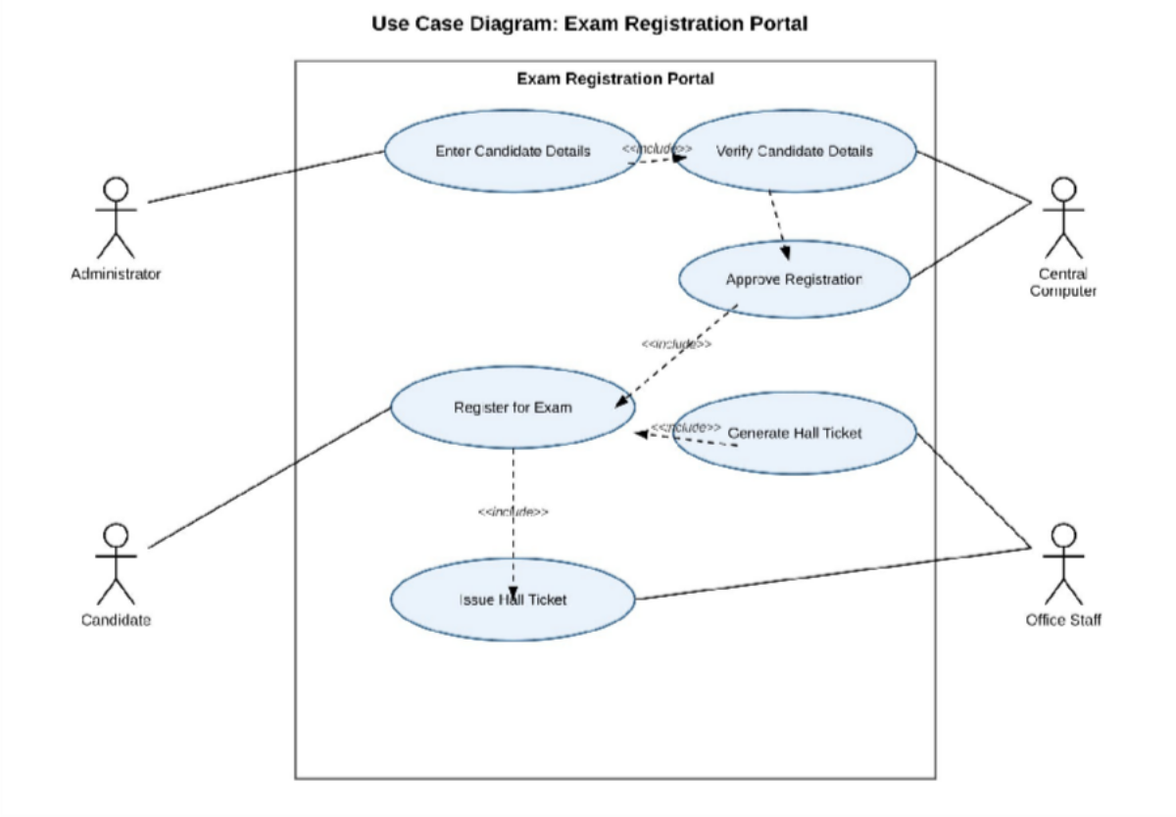
Fig. 2.1 — Use Case Diagram of the Exam Registration Portal

The Administrator's Enter Candidate Details use case includes (<<include>>) the Verify Candidate Details use case executed by the Central Computer. A successful verification leads to the Approve Registration use case. The Candidate performs the Register for Exam use case, which is required before the office can Generate Hall

Ticket (<<include>> Approve Registration) and subsequently Issue Hall Ticket (<<include>> Register for Exam), ensuring hall tickets are issued only to registered, approved candidates.

Classes Identified

Class | Key Attributes | Key Operations
Candidate | candidateId, name, rollNo, courseName, semester | registerForExam(), viewHallTicket()
Administrator | adminId, name | enterCandidateDetails()
CentralComputer | systemId | verifyDetails(), grantApproval()
Office | officeId | generateHallTicket(), issueHallTicket()
Exam | examId, examName, examDate, venue | scheduleExam()
HallTicket | ticketId, candidateId, examId, seatNo, issueDate | generate(), print()

Class Diagram
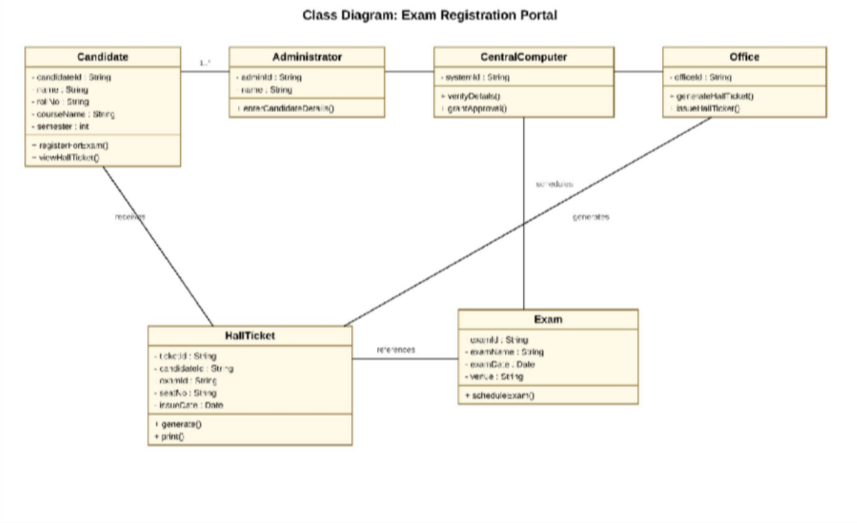
Fig. 2.2 — Class Diagram of the Exam Registration Portal

Candidate and Administrator share a 1..* association, mirroring the real-world flow where one administrator processes many candidates. The CentralComputer schedules the Exam class and, on approval, the Office generates a HallTicket for the Candidate. Each HallTicket references the corresponding Exam, tying together the candidate, the examination, and the issued ticket.

Analysis of Relationships
Introducing HallTicket as a distinct class (rather than embedding ticket data inside Candidate) keeps the design normalized: a candidate may, over time, be associated with multiple hall tickets across different exams.

Similarly, keeping Exam separate from HallTicket allows exam scheduling (venue, date) to be managed independently of ticket issuance, which is a realistic and extensible design choice.

Question 3: Stock Maintenance System

Problem Statement
The Stock Maintenance System allows a customer to place orders and purchase items with the assistance of a stock dealer and the central stock system. Orders placed by the customer are verified by the central stock system; once verified, the items are delivered to the customer by the stock dealer, and the stock details are updated accordingly.

Actors Identified

Actor | Role in the System
Customer | Places orders and purchases items from the stock system.
Stock Dealer | Receives and forwards customer orders, and delivers items to the customer.
Central Stock System | Verifies orders and updates the stock details after a transaction.

Use Case Diagram
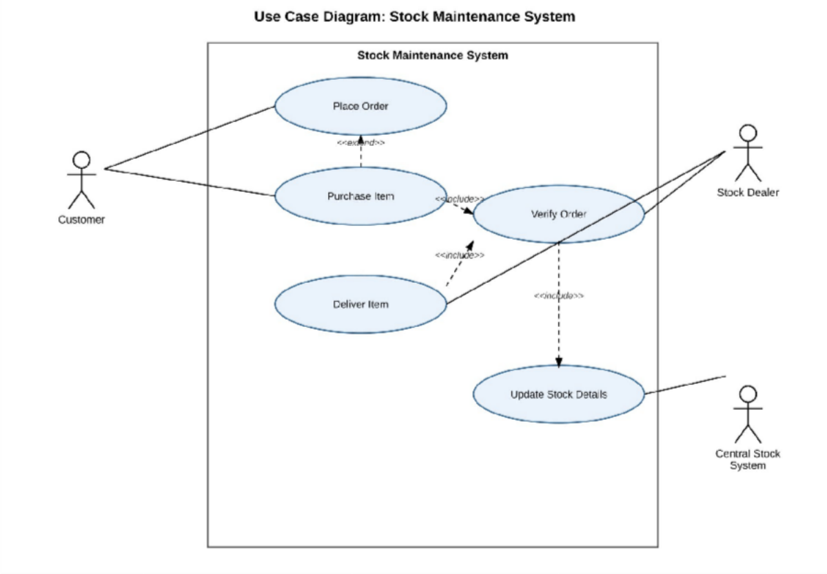
Fig. 3.1 — Use Case Diagram of the Stock Maintenance System

The Customer performs the Place Order use case, which is extended (<<extend>>) by the Purchase Item use case for direct purchases. Purchase Item includes (<<include>>) the Verify Order use case, which is carried out by the Stock Dealer together with the Central Stock System. The Deliver Item use case (Stock Dealer) also includes Verify Order, ensuring that items are dispatched only after the order has been verified. Verify Order in turn includes the Update Stock Details use case, so that stock quantities are kept consistent with every verified transaction.

Classes Identified

Class | Key Attributes | Key Operations
Customer | customerId, name, address, contactNo | placeOrder(), purchaseItem()
StockDealer | dealerId, name | receiveOrder(), forwardOrder(), deliverItem()
CentralStockSystem | systemId | verifyOrder(), updateStock()
Order | orderId, customerId, itemId, quantity, orderDate, status | createOrder(), confirmOrder()
Item | itemId, itemName, price, quantityAvailable | checkAvailability(), updateQuantity()
Delivery | deliveryId, orderId, deliveryDate, status | scheduleDelivery(), confirmDelivery()

Class Diagram
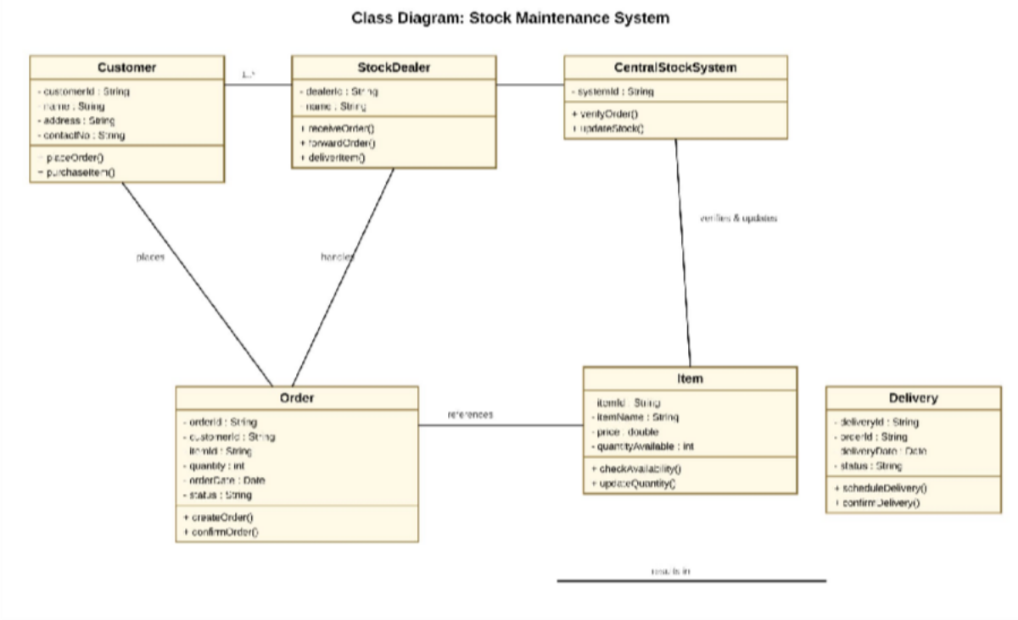
Fig. 3.2 — Class Diagram of the Stock Maintenance System

A Customer places an Order, which the StockDealer handles; the Order references an Item, and the CentralStockSystem verifies the order and updates the Item's stock. Each processed Order results in a Delivery, which records the dispatch of the purchased items to the customer.

Analysis of Relationships
Separating Order, Item, and Delivery into distinct classes reflects three different lifecycles in the domain: an order is created once, an item's stock level changes continuously, and a delivery happens after fulfilment. This separation allows the CentralStockSystem to independently manage stock accuracy (via Item) while the StockDealer manages logistics (via Delivery), which is essential for a scalable and maintainable stock maintenance system.

Question 4: Online Course Reservation System

Problem Statement
The Online Course Reservation System is organized by the central management system of the university. A student browses the available courses and selects the desired course. The university (central management system) then checks the availability of seats for that course; if a seat is available, the student is enrolled in the course and the enrollment is confirmed.

Actors Identified

Actor | Role in the System
Student | Browses the available courses and selects the desired course.
University (Central Management System) | Checks seat availability, enrolls the student, and confirms enrollment.

Use Case Diagram
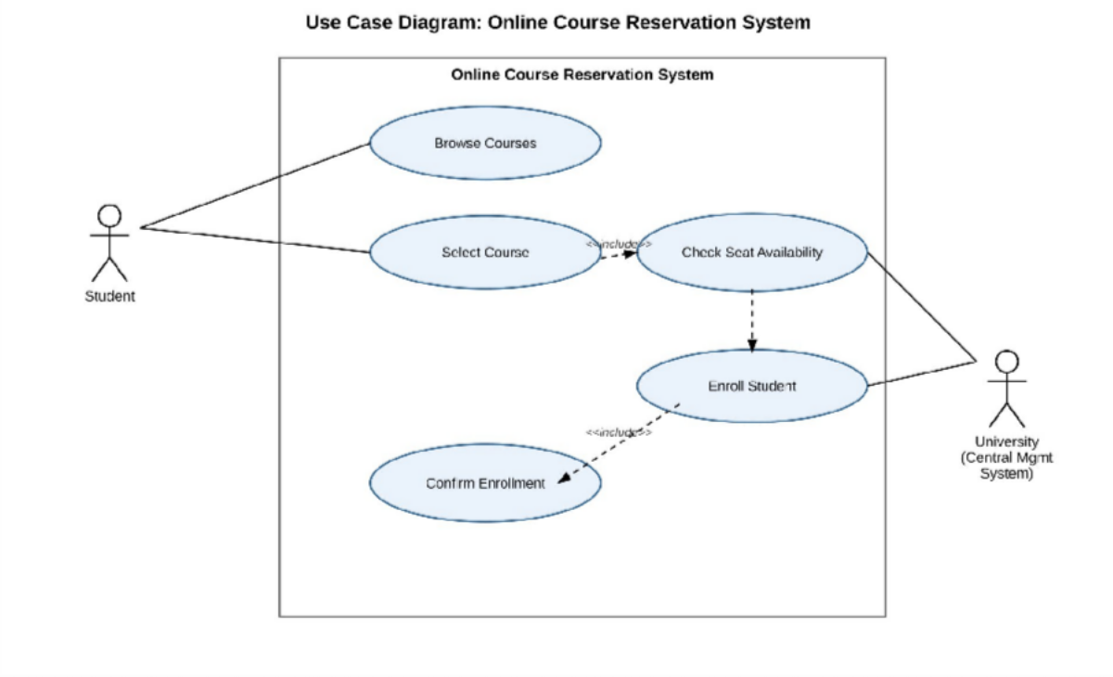
Fig. 4.1 — Use Case Diagram of the Online Course Reservation System

The Student performs the Browse Courses and Select Course use cases; Select Course includes (<<include>>) the Check Seat Availability use case, which is carried out by the University's central management system. If seats are available, the system proceeds to the Enroll Student use case, which includes the Confirm Enrollment use case, completing the reservation process for the student.

Classes Identified

Class | Key Attributes | Key Operations
Student | studentId, name, email, department | browseCourses(), selectCourse(), viewEnrollmentStatus()

Class | Key Attributes | Key Operations
CentralManagementSystem | systemId | checkAvailability(), enrollStudent(), sendConfirmation()
Course | courseId, courseName, instructor, seatsAvailable, credits | checkSeats(), updateSeats()
Enrollment | enrollmentId, studentId, courseId, enrollmentDate, status | createEnrollment(), confirm()

Class Diagram
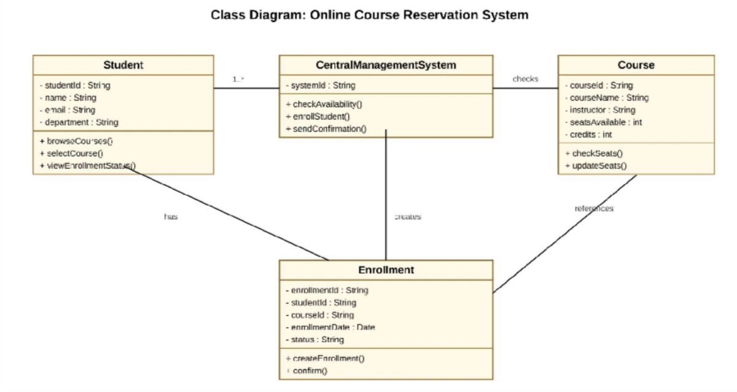
Fig. 4.2 — Class Diagram of the Online Course Reservation System

The Student is associated (1..*) with the CentralManagementSystem, which checks the Course class for seat availability. On successful enrollment, the CentralManagementSystem creates an Enrollment linked to the Student, and each Enrollment references the corresponding Course.

Analysis of Relationships
The Enrollment class functions as an association class between Student and Course, capturing transaction-specific data (enrollmentDate, status) that would otherwise require a many-to-many relationship to be handled awkwardly. This design allows a student to enroll in multiple courses and a course to have multiple enrolled students, while the seat count on Course is kept authoritative and updated centrally by the CentralManagementSystem, preventing over-enrollment.

Conclusion
The four systems — Book Bank Management, Exam Registration, Stock Maintenance, and Online Course Reservation — were each analyzed using object-oriented techniques to identify actors, use cases, classes, attributes, operations, and relationships, as required by Course Outcome CO3. In every case, a verifying/central authority (Central Computer, Central Stock System, or Central Management System) mediates between the requester and the fulfilling party, and this responsibility split was captured through
<<include>> and <<extend>> relationships in the Use Case Diagrams and through associations, 1..* multiplicities, and association classes (BookBankRecord, HallTicket, Delivery, Enrollment) in the Class Diagrams. This consistent modeling approach demonstrates a systematic, well-planned application of UML notation to real-world administrative workflows.

